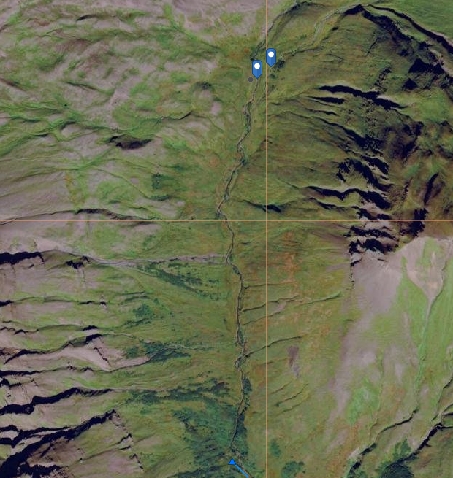
Current Upper Reach AWC 283-80-10900-2013
55.602779, -160.739901
Trib AWC 283-80-10900-2013
55.602779, -160.740571
Mainstem AWC 283-80-10900-2013
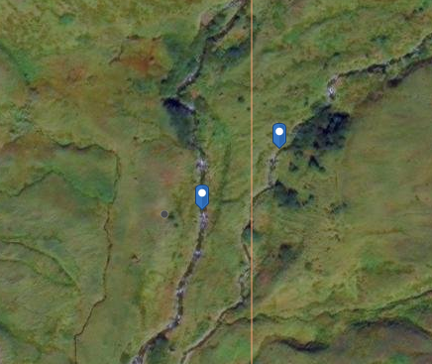
55.602779, -160.739901
Trib AWC 283-80-10900-2013
55.602779, -160.740571
Mainstem AWC 283-80-10900-2013
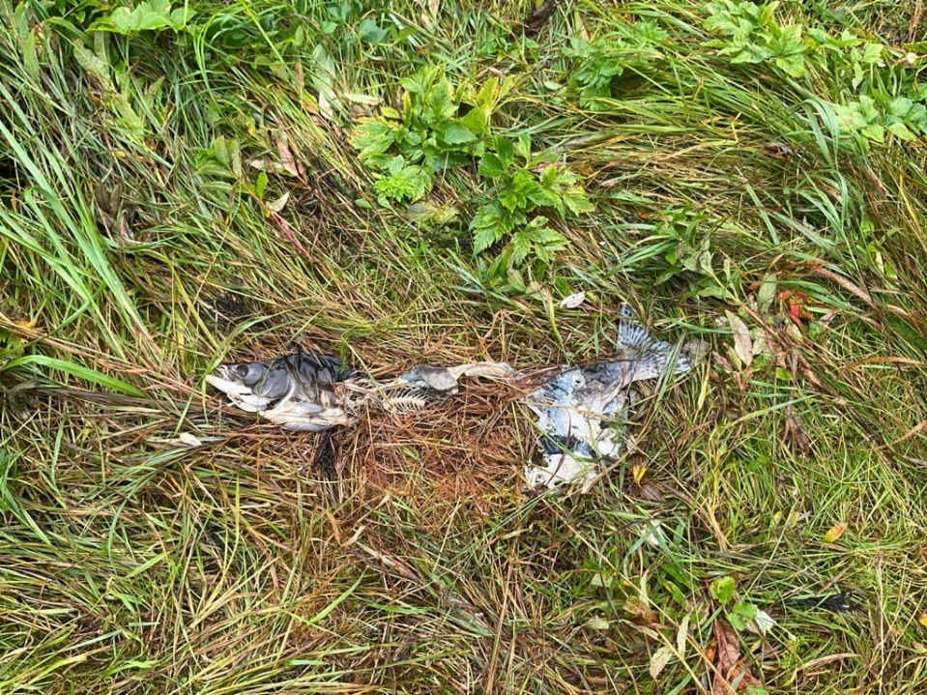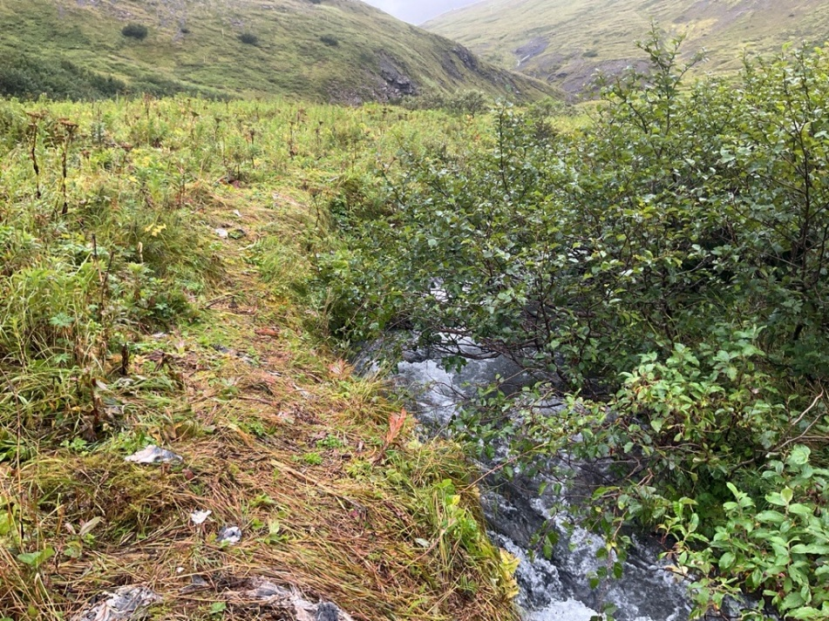
Pink salmon carcasses along bear trail.
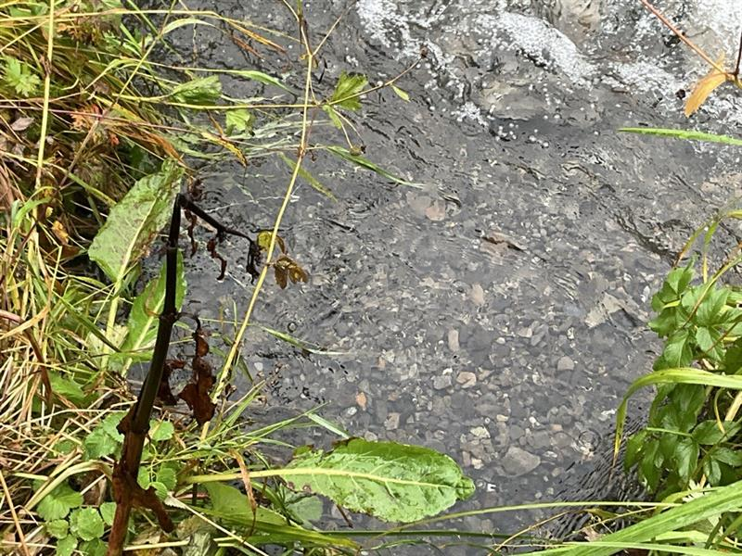
redd with adult pink (behind foliage)

